Computer Operating System Quiz

Answer to the questions

    - Explain the following computer hardware components:

1. Screen
A computer display, monitor or screen is a computer device capable of showing still or moving images generated by a computer and processed by a graphics card.
2 marks
2. Keyboard
Keyboards are designed for the input of text and characters, and also to control the operation of the computer. Physically, computer keyboards are an arrangement of rectangular or near-rectangular buttons, or "keys". Keyboards typically have characters engraved or printed on the keys; in most cases, each press of a key corresponds to a single written symbol. However, to produce some symbols requires pressing and holding several keys simultaneously, or in sequence; other keys do not produce any symbol, but instead affect the operation of the computer, or the keyboard itself.
2 marks

3.Mouse
A mouse is a handheld pointing device for computers. It is a small object fitted with one or more buttons and shaped to sit naturally under the hand.
The underside of the mouse houses a device that detects the mouse's motion. It is called a mouse primarily because the cord on early models resembled the rodent's tail, and also because the motion of the pointer on the screen can be mouse-like.
2 marks

4.System Unit
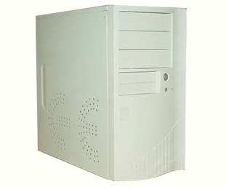
Usually a beige or dark grey box, or if a Mac Monitor Style or Aluminum Box, it is the most essential part of the computer. It houses the processor (the ‘brain’), the various kinds of memory and the electronics to control all the other components. It also usually includes a fan, designed to keep the whole unit cool. The fan is responsible for the hum from the computer when you turn it on. The system unit may stand vertically on the floor (a tower) or horizontally on the desk, usually with the screen on top (a desktop unit). In a laptop or notebook computer, the system unit is usually built underneath the keyboard.
5 marks

5. Central Processing Unit
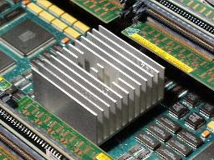
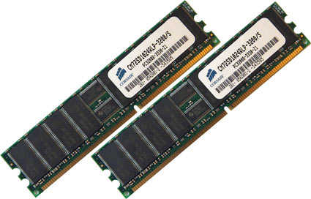
The processor chip and the electrics that support it are known as the central processing unit. The CPU is at the heart of the computer within the system unit, it performs calculations, controls logic flow and communicates with and controls the operation of the other parts of the computer system.
5 marks

6. Memory
There are a number of different kinds of memory, two of which are commonly talked about- Random Access Memory (RAM) and disk space. RAM is the computer’s working memory, an important factor in determining a computer’s speed. RAM is volatile, which means as soon as the power is turned off, whatever was in RAM is lost.

Another type of memory is called Read-Only Memory (ROM). ROM is where the computer stores its low level programs, the ones that tell the computer how to behave and how to treat different types of input devices. ROM differs from RAM in the way that it is not changed after the computer is assembled (you can read it, but not write to it).

Disk space is another type of memory. A disk is a device for storing information.

Disks record information in a similar way as music or video tapes, once information is recorded to a disk it remains there until it is changed or deleted.

The hard disk located in the computer (usually called the ‘C’ drive) (Windows) or Hard Drive (Mac) is a spinning magnetic disk on which computer data can be stored.
5 marks

7.Sound Card
A sound card is a piece of hardware that can be inserted into the motherboard of the computer to input and output sound under the control of computer programs
5 marks

2. Explain the following computer peripherals:

8. A Printer is…
a device that produces a hard copy of text and/or graphics. A hard copy is a physical reproduction of documents stored in electronic form, usually onto a medium such as paper.
5 marks

9. A Scanner is used to…digitalizes a two dimensional image, such as sending a picture from a book to the computer screen, is used to input physical items or printed text and images into the computer.
5 marks

10. A Modem allows you to… to connect the computer to the telephone network, allowing access to the internet and emails to be sent and received. Most computers today include a modem already installed in the system unit, but they can also be obtained as an external device that can be connected to the computer with a cable. Most modems can also enable your computer to function as a fax machine.
5 marks

11. Explain the difference between a CD-R, CD-RW, DVD-R and DVD-RW
A CD-R is able to be written to and therefore store either music or data in its memory. This information cannot be deleted or over written. Whereas A CD-RW is a CD that is able to be written to and store information, although the information is also able to be deleted or over written, and further information can be added to the disc.

A DVD-R is a CD with larger data storage capacity than a CD-R. It is used to store large amounts of data such as movies, whereas a DVD-RW is a DVD with equal storage capacities to a DVD-R, used to hold large amounts of data. The difference is the fact that a DVD-RW has the ability to erase and rewrite data to the disc.
5 marks

12. Explain an Ergonomic principle to help avoid eye strain
Take regular breaks use good lighting
2 marks

13. Explain an Ergonomic principle to help avoid physical strain.
Adjust chairs, monitors and computers to correct position, in relation to your body take breaks to ease overuse syndrome
2 marks

14. Describe the function of a computer operating system.
An operating system (OS) is a software program that manages the hardware and software resources of a computer. The OS performs basic tasks, such as controlling and allocating memory, prioritizing the processing of instructions, controlling input and output devices, facilitating networking, and managing files. A computer must have an operating system to be able to run other programs. An operating system can also be referred to as a computer platform.

First, the operating system rules the computer's roost, controlling all the individual computer components and making sure that everything gets along well. It's the actual brains of the operation, telling the hardware what to do next.
5 marks
15. Describe the boot process.
The typical computer system boots over and over again with no problems, starting the computer's operating system (OS) and identifying its hardware and software components that all work together to provide the user with the complete computing experience. But what happens between the time that the user powers up the computer and when the GUI icons appear on the desktop?
In order for a computer to successfully boot, its BIOS, operating system and hardware components must all be working properly; failure of any one of these three elements will likely result in a failed boot sequence.
5 marks

16. What is the relationship between an application program, the operating system and hardware?
Application program must be suited to the operating system and have sufficient RAM to work effectively, the hardware being the CPU and peripherals should be able to manage the requirements of the application such as colour printer, stereo speakers.
5 marks

17. What are the general differences between the different computer platforms and their respective operating systems.

Windows uses a variety of operating systems such as 2000, XP, Vista and is text driven, it has only one resource fork and therefore is susceptible to viruses.

Mac uses OS (Operating System 10) and is mainly graphical but uses two file identifiers the resource forck and a data fork and is therefore more secure from viruses.

Linux is a more sophisticated system and has more stability than the Windows computer.

18. Draw a simple block diagram showing the interconnection of the various components of a computer.

5 marks

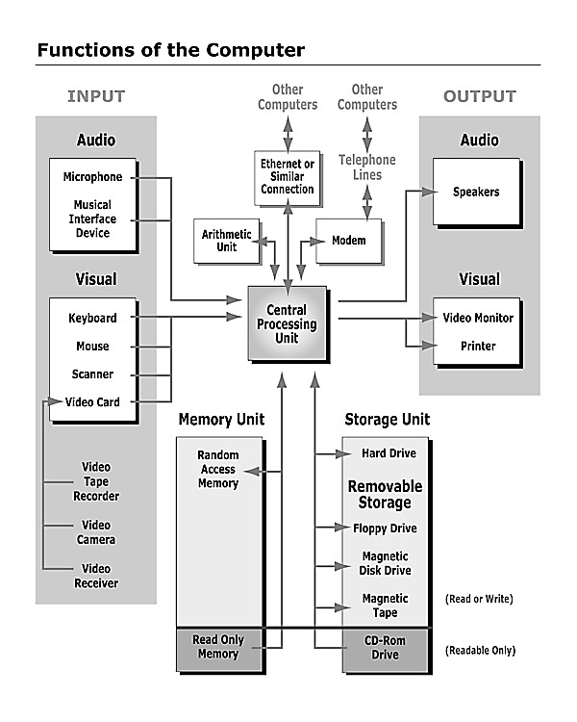
Answer:

- Write the name of the external hardware components and peripherals on the following diagram
Answers:

5 marks
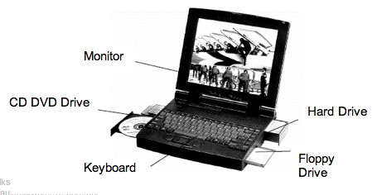

20. Label the parts on these computers
Answers:
Use text boxes to line up your answers
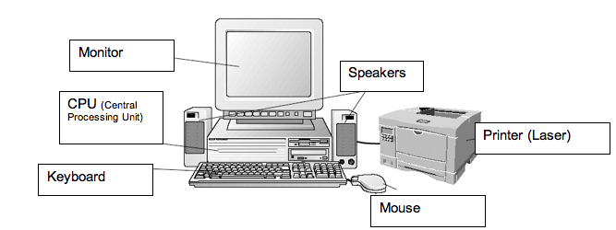
5 marks

21. Describe the functions of computer hardware and associated OH&S standards and environmental considerations around hardware use and disposal of equipment

The manufacture of computers is a highly resource-intensive process that
uses significant quantities of energy, water and raw materials. In addition,
PCs contain hazardous materials that can be toxic to human health.
Therefore, from an environmental perspective, it is usually preferable to delay
disposal, which has the effect of ‘reducing consumption’ of PCs
and thereby reducing the environmental impacts associated with PC
manufacture. This involves considering whether disposal is really necessary
or whether it is possible to extend the useful life of the PC. Extension of useful
life could be achieved by considering whether an upgrade or modification of
the PC is possible, or whether the PC can be used to perform other functions
(for example, those less technologically demanding) elsewhere within the
business.

5 marks

22. Label each of the following as hardware or software.
Use text boxes to line up your answers

5 marks

Answer: Mouse, Scanner, Printer, Applications, Applications, Dot Matrix Printer, Tape Drive, Application
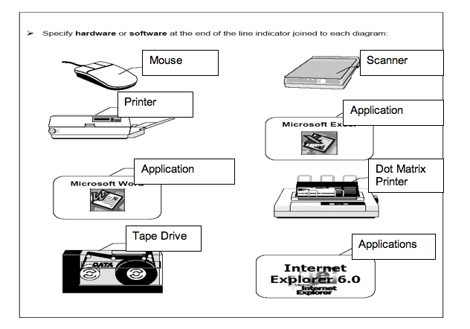
(Use text boxes)

---------------End of Quiz --------

Teacher Notes

Following are useful notes to help with answers

Notes and information pages to help you answer these questions (can be printed separately and given out as an adjunct to taking the Computer Operating System Quiz

If you have old computers that can be disassembled it would help.
You will need to disassemble (and re-assemble) a computer (provided in class to help with these tasks)

A computer is a tool used to perform calculations and store the results.
They are used in businesses, in the home, in schools and in the entertainment industry. A ‘computer’ is not just the box sitting on your office desk, but it is the thing inside your washing machine that controls the washing cycles, the thing in your telephone that holds numbers, the device in your VCR’s, stereo, microwave oven and even your watch.

A computer can be thought of as a device which accepts information, processes it and produces an outcome.

E.g.
INPUT
PROCESSING
OUTPUT

Mathematical sum Working the sum out Answer to mathematical sum
Search for a movie Searching for the movie Time of movie
time on the internet

The input is the information you put into the computer, the output is the result of the information put in, and what happens in between, inside the computer to reach the outcome is called the processing.

Computers are general purpose machines, made up of two components:
Hardware (physical parts of a computer)
Software (programs that make the computer work)

What is Computer Hardware?

Computer hardware is the physical parts that make up a computer. It includes the keyboard, the mouse, the screen, and the parts inside the computer.

EXTERNAL HARDWARE:
Screen
A computer display, monitor or screen is a computer device capable of showing still or moving images generated by a computer and processed by a graphics card.

Keyboard
Keyboards are designed for the input of text and characters, and also to control the operation of the computer. Physically, computer keyboards are an arrangement of rectangular or near-rectangular buttons, or "keys". Keyboards typically have characters engraved or printed on the keys; in most cases, each press of a key corresponds to a single written symbol. However, to produce some symbols requires pressing and holding several keys simultaneously, or in sequence; other keys do not produce any symbol, but instead affect the operation of the computer, or the keyboard itself.

Mouse
A mouse is a handheld pointing device for computers. It is a small object fitted with one or more buttons and shaped to sit naturally under the hand.
The underside of the mouse houses a device that detects the mouse's motion. It is called a mouse primarily because the cord on early models resembled the rodent's tail, and also because the motion of the pointer on the screen can be mouse-like.

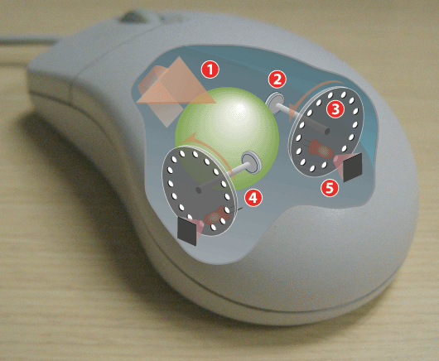
Operating a mechanical mouse
1: Moving the mouse turns the ball.
2: X and Y rollers grip the ball and transfer movement.
3: Optical encoding disks include light holes.
4: Infrared LEDs shine through the disks.
5: Sensors gather light pulses to convert to X and Y velocities.

The System Unit
Usually a beige or dark grey box, it is the most essential part of the computer. It houses the processor (the ‘brain’), the various kinds of memory and the electronics to control all the other components. It also usually includes a fan, designed to keep the whole unit cool. The fan is responsible for the hum from the computer when you turn it on. The system unit may stand vertically on the floor (a tower) or horizontally on the desk, usually with the screen on top (a desktop unit). In a laptop or notebook computer, the system unit is usually built underneath the keyboard.

Universal Serial Bus (USB)
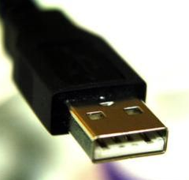
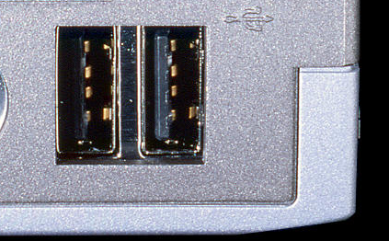
A hot swappable standard for connecting devices to computers- meaning that the device can be connected and disconnected while the computer is turned on.

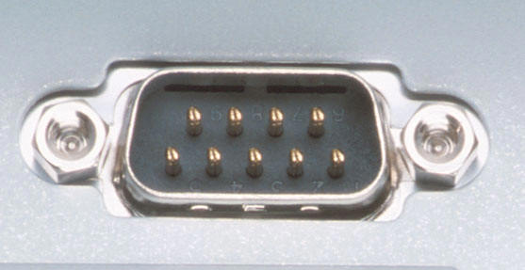
Serial ports
A serial port is a plug located on the system unit or tower of a computer, used to connect other external hardware, such as a mouse or keyboard.

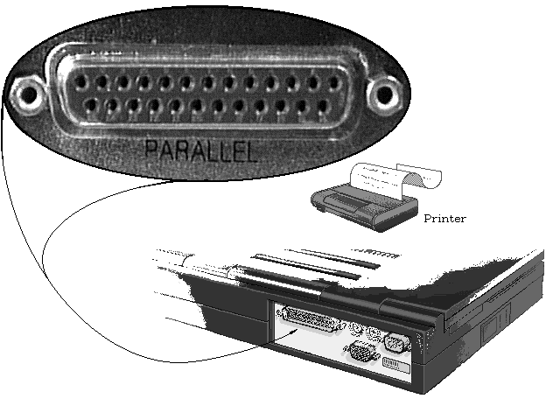
Parallel ports
A parallel port is a plug located on the system unit or tower of a computer, used to connect other external hardware, such as a printer or scanner. It transmits 1 byte of information at a time parallel to each other, meaning it is capable of sending data faster than a serial port.

INTERNAL HARDWARE:
Central Processing Unit (CPU)
The processor chip and the electrics that support it are known as the central processing unit. The CPU is at the heart of the computer within the system unit, it performs calculations, controls logic flow and communicates with and controls the operation of the other parts of the computer system.

Memory
There are a number of different kinds of memory, two of which are commonly talked about- Random Access Memory (RAM) and disk space. RAM is the computer’s working memory, an important factor in determining a computer’s speed. RAM is volatile, which means as soon as the power is turned off, whatever was in RAM is lost.

Another type of memory is called Read-Only Memory (ROM). ROM is where the computer stores its low level programs, the ones that tell the computer how to behave and how to treat different types of input devices. ROM differs from RAM in the way that it is not changed after the computer is assembled (you can read it, but not write to it).

Disk space is another type of memory. A disk is a device for storing information.

Disks record information in a similar way as music or video tapes, once information is recorded to a disk it remains there until it is changed or deleted.

The hard disk located in the computer (usually called the ‘C’ drive) (Windows) or Hard Drive (Mac) is a spinning magnetic disk on which computer data can be stored.

Motherboard
A motherboard also known as the main board is the central or primary circuit board making up a computer system.
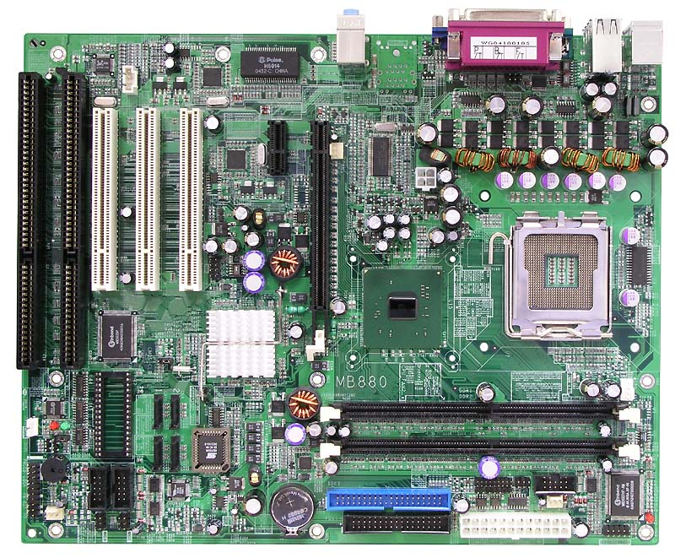

Network Interface Card
This is a piece of hardware that allows computers to communicate over a computer network.
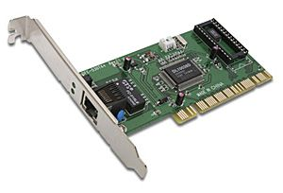

Sound Card
A sound card is a piece of hardware that can be inserted into the motherboard of the computer to input and output sound under the control of computer programs.
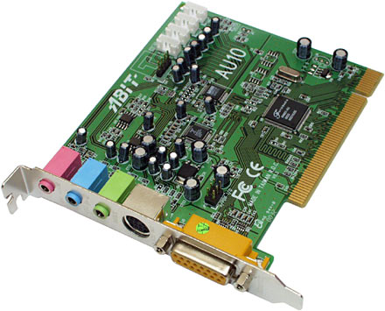

Cable
A cable is two or more wires or optical fibers bound together, typically in a common protective jacket or sheath. The individual wires or fibers inside the jacket may be bare, covered or insulated.
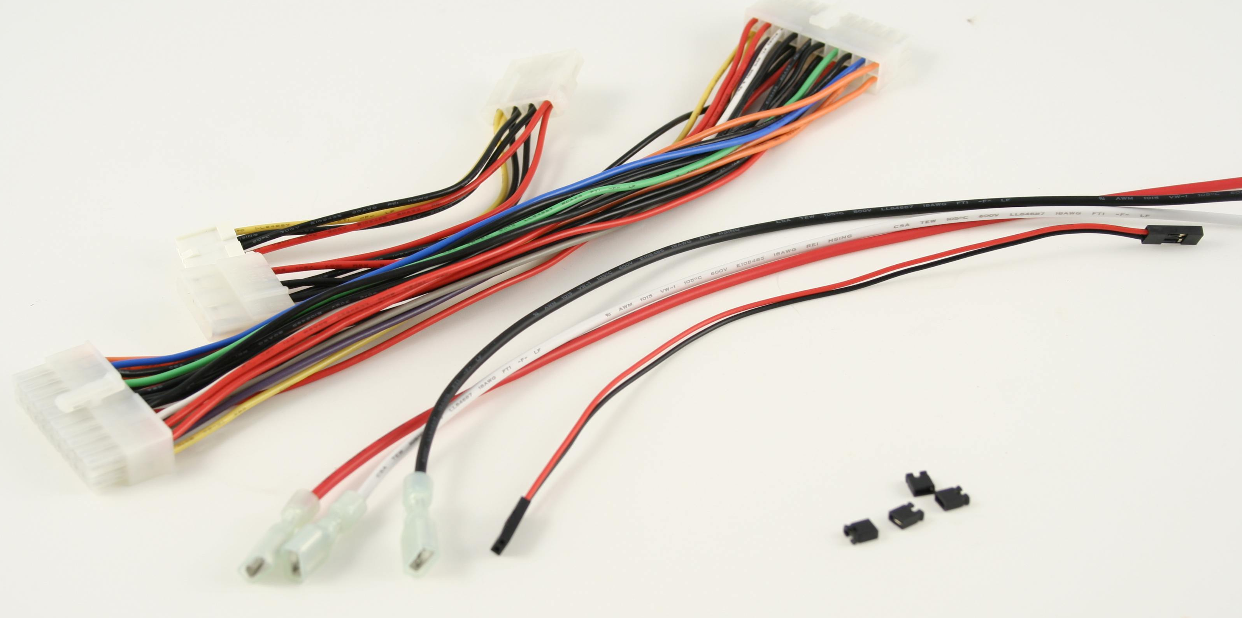

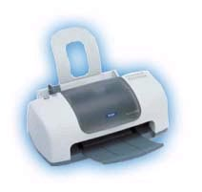
COMPUTER PERIPHERALS:
Printer
A printer is a device that produces a hard copy of text and/or graphics. A hard copy is a physical reproduction of documents stored in electronic form, usually onto a medium such as paper.

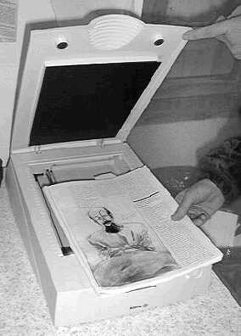
Scanner
An image scanner is a general purpose device which digitalizes a two dimensional image, such as sending a picture from a book to the computer screen, is used to input physical items or printed text and images into the computer.

Tape Cartridge
A tape cartridge is a device that reads and writes data stored on magnetic tape or a punched tape. It is used for storage of data on hard drives.
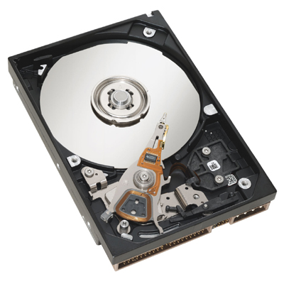

Speakers
A speaker is a computer external device that reproduces speech and/or music
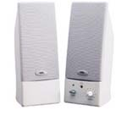

Modem
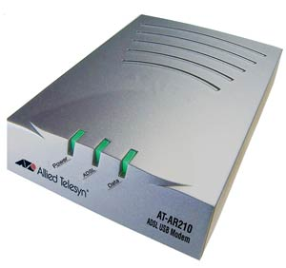
A modem is a device used to connect the computer to the telephone network, allowing access to the internet and emails to be sent and received. Most computers today include a modem already installed in the system unit, but they can also be obtained as an external device that can be connected to the computer with a cable. Most modems can also enable your computer to function as a fax machine.

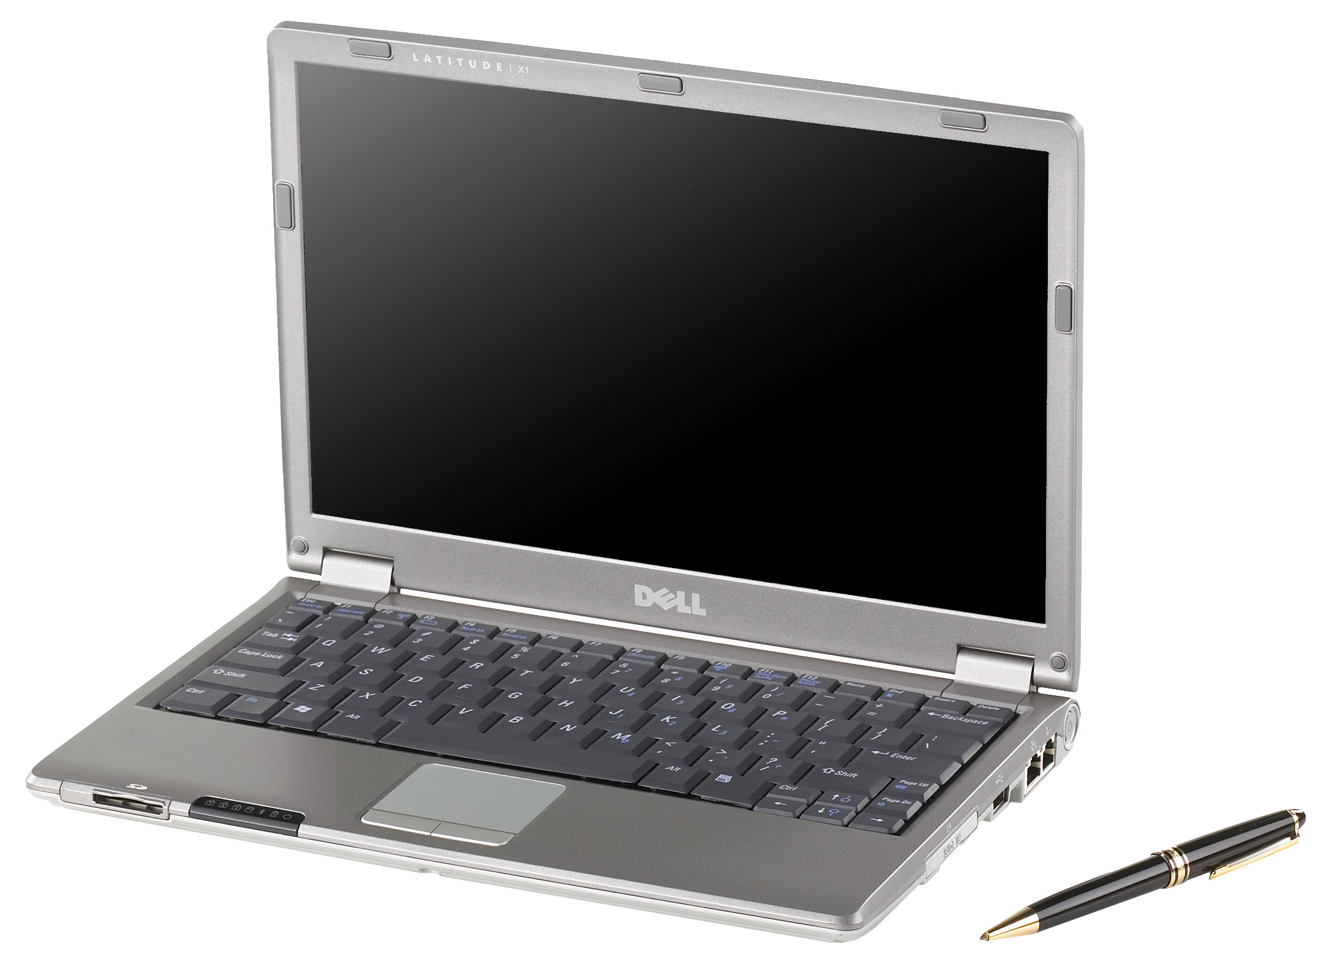
Laptop Computer
A laptop computer or notebook computer is a small portable computer.

Bluetooth device
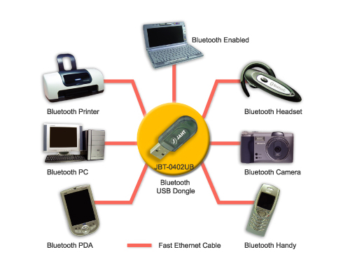
Bluetooth is a technical requirement for wireless Personal Area Networks (PANs). PANs are networks that allow access to personal devices such as the telephone, personal digital assistants (organisers), or digital cameras.

Compact Disc-Recordable (CD-R)
A CD-R is a variation of a Compact or Optical Disc (CD), in the way that it is able to be written to and therefore store either music or data in its memory. This information cannot be deleted or over written.
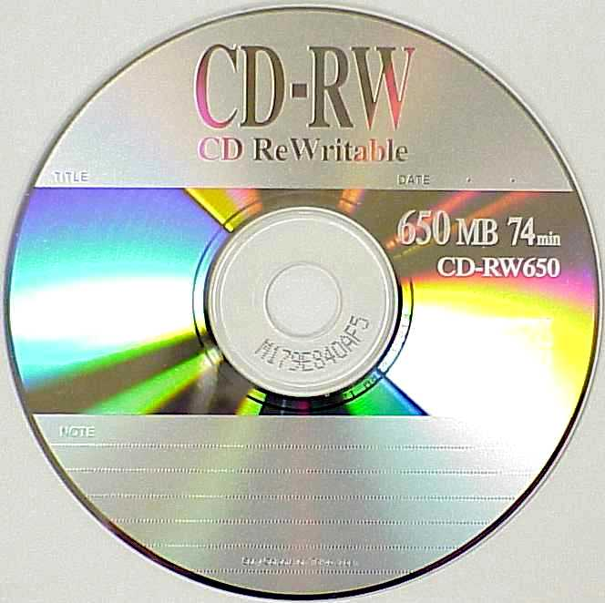
Compact Disc-Rewritable (CD-RW)
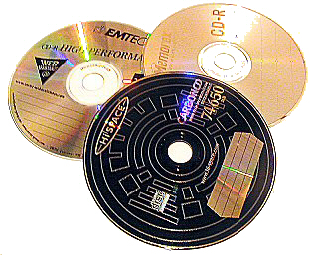
A CD-RW is a CD that is able to be written to and store information, although the information is also able to be deleted or over written, and further information can be added to the disc.

Digital Video Disc-Recordable (DVD-R)
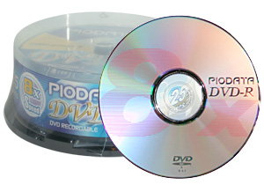
A DVD-R is a CD with larger data storage capacity than a CD-R. It is used to store large amounts of data such as movies.
Digital Video Disc Rewritable (DVD-RW)
A DVD-RW is a DVD with equal storage capacities to a DVD-R, used to hold large amounts of data. The difference is the fact that a DVD-RW has the ability to erase and rewrite data to the disc.
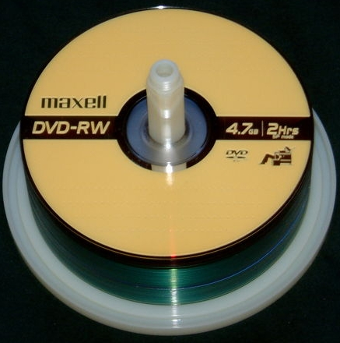

What is Computer Software?

Computer software is the programs that make the computer function. They are the instructions that tell a computer what to do. It includes applications software and system software.

Application software includes programs such as Microsoft Word and Excel. They are the programs which produce documents or those that do not concern the internal functioning of the actual computer, such as a game.

Application software is a loosely defined subclass of computer software that employs the capabilities of a computer directly to a task that the user wishes to perform. This should be contrasted with system software which is involved in integrating a computer's various capabilities, but typically does not directly apply them in the performance of tasks that benefit the user. The term application refers to both the application software and its implementation.

System software includes the programs that involve the computer itself, such as those that control sending messages to the printer, messages to the computer from the keyboard, and how to manage files.

What is a Computer Operating System?
An operating system (OS) is a software program that manages the hardware and software resources of a computer. The OS performs basic tasks, such as controlling and allocating memory, prioritizing the processing of instructions, controlling input and output devices, facilitating networking, and managing files. A computer must have an operating system to be able to run other programs. An operating system can also be referred to as a computer platform.
First, the operating system rules the computer's roost, controlling all the individual computer components and making sure that everything gets along well. It's the actual brains of the operation, telling the hardware what to do next.
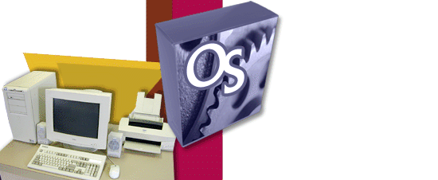

Next, the operating system controls applications software.
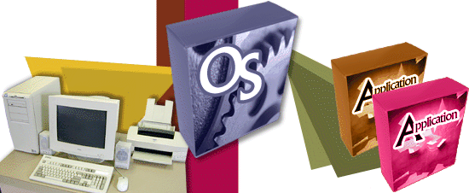

Finally, it's the operating system's job to communicate with you.
The operating system typically comes with the computer when you buy it. You never need to add a second operating system, although operating systems do get updated and improved from time to time.

For the PC, the operating system is usually Windows. It comes in various flavours: Windows 98, Windows Me, Windows 2000, and Windows XP.
When you buy software, you buy it for an operating system, not your brand of PC. In the olden days (the 1980s), you would walk to the Apple or IBM or Commodore section of the software store. Today, you browse either in the Macintosh or Windows or even Linux aisles

Some examples of computer operating systems include Microsoft Windows, Mac OS, Unix and Linux

Microsoft Windows

This operating system was developed by the company Microsoft in November of 1985. It was designed for use on personal computers. It is now estimated that 90% of the operation system market is dominated by Microsoft Windows.

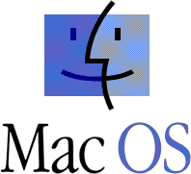
Mac OS
This operating system was developed by the company Apple Computer for their line of Macintosh computers in 1984. Mac OS stands for Macintosh Operating System.

Unix
This operating system was developed in the 1960’s and 1970’s by a group of Bell’s Labs employees including Ken Thompson, Dennis Ritchie, and Douglas McIlroy. The Unix operating system was designed to be portable, multi tasking and multi user friendly.

Linux
This operating system is also known as GNU, and was developed and used initially by individual enthusiasts. It is a free program available to the public to freely use, modify and redistribute.

Starting the Computer

The action of turning a computer on or ‘booting’ or ‘powering’ up is the first step in operating the computer hardware and software.

The first step in the boot process (turning on) is to make sure the computer is plugged into the electricity socket. Then press the button to switch the computer on, and wait for it to warm up.

While it is warming up it will make some noise and letters and numbers will flash on the screen. These noises and words are the computer checking that everything is in working order.

Once the computer has finished warming up a coloured screen will appear.
Depending on your computer, the screen could be one with pictures asking which user you are, or it may go straight to the Windows desktop.

The Windows desktop is the screen with pictures against a coloured background, and a bar along the bottom of the screen with a button in the left corner called the
‘start’ button.
If it goes straight to this Windows desktop, you have completed the boot process to start your computer.

If it is asking you which user you are, you merely have to just use the mouse to click on the appropriate user name, and it will then go on to the Windows desktop described earlier.

The System Boot Process Explained
The typical computer system boots over and over again with no problems, starting the computer's operating system (OS) and identifying its hardware and software components that all work together to provide the user with the complete computing experience. But what happens between the time that the user powers up the computer and when the GUI icons appear on the desktop?
In order for a computer to successfully boot, its BIOS, operating system and hardware components must all be working properly; failure of any one of these three elements will likely result in a failed boot sequence.

When the computer's power is first turned on, the CPU initializes itself, which is triggered by a series of clock ticks generated by the system clock. Part of the CPU's initialization is to look to the system's ROM BIOS for its first instruction in the startup program. The ROM BIOS stores the first instruction, which is the instruction to run the power-on self test (POST), in a predetermined memory address. POST begins by checking the BIOS chip and then tests CMOS RAM. If the POST does not detect a battery failure, it then continues to initialize the CPU, checking the inventoried hardware devices (such as the video card), secondary storage devices, such as hard drives and floppy drives, ports and other hardware devices, such as the keyboard and mouse, to ensure they are functioning properly.

Once the POST has determined that all components are functioning properly and the CPU has successfully initialized the BIOS looks for an OS to load.
The BIOS typically looks to the CMOS chip to tell it where to find the OS, and in most PCs, the OS loads from the C drive on the hard drive even though the BIOS has the capability to load the OS from a floppy disk, CD or ZIP drive. The order of drives that the CMOS looks to in order to locate the OS is called the boot sequence, which can be changed by altering the CMOS setup. Looking to the appropriate boot drive, the BIOS will first encounter the boot record, which tells it where to find the beginning of the OS and the subsequent program file that will initialize the OS.

Once the OS initializes, the BIOS copies its files into memory and the OS basically takes over control of the boot process. Now in control, the OS performs another inventory of the system's memory and memory availability (which the BIOS already checked) and loads the device drivers that it needs to control the peripheral devices, such as a printer, scanner, optical drive, mouse and keyboard. This is the final stage in the boot process, after which the user can access the system’s applications to perform tasks.

What is inside a Computer?
Today, we are going to rip apart a computer and see what is inside it? We will see and learn about:
Power Supply: supplies electricity to all components.
Motherboard: the main and central part of a computer.
Ports: for sending and receiving data from outside.
Serial (9 pin) => Slow,
Parallel (25 pins) => Fast,
USB (Universal Serial Bus) => Very Fast.
Slots: for connecting different components to the motherboard.
ISA (Industry Standard Architecture),
PCI (Peripheral Component Interconnect),
AGP (Accelerated Graphics Port),
RAM (Random Access Memory).
Memory: for temporary storage of program data.
RAM (Random Access Memory),
ROM (Read Only Memory).
CPU (Central Processing Unit): The brain of computer gets hot!
Intel: 286, 486, Celeron, Pentium I, Pentium II, ....
Hard drive: for storing programs and data.
Floppy drives: used for storing/transferring small amount of data.
5.25 inch (old, 1.2 MB),
3.5 inch. (new, 1.44 MB).
CDROM drive (Compact Disc Read Only Memory),
Graphics card: for connecting to a monitor,
Modem: for connecting to the Internet using a phone line,
Ethernet card: for fast connection to the Internet,
SCSI card (Small Computer System Interface): for fast connection components,
Sound card: for connecting to speakers, headphone, and microphone.
Acronyms:
BPS = Bits Per Second
OS = Operation System : example: Windows, Apple (Mac), Linux, Unix, ...
PC = Personal Computer
KB = Kilo Byte
MB = Mega Byte
MHz = Mega Hertz
GHz = Giga Hertz
Kilo = 1000
Mega = 1000,000
Giga = 1000,000,000

The Workings of the Computer
Probably no technology has had a more profound effect upon copyright, upon the creative process, or, for that matter, upon our lives, than the computer. Before getting into the intricacies of copyright, however, it will be helpful to spend just a little time exploring what computers are and how they work.

The Hardware

The real guts of most computers is the central processing unit, or CPU. (The underlined key phrases are illustrated in the diagram on this page.) Basically, this central processing unit is a very fast traffic cop. It receives information, in the form of electronic impulses, and reroutes it to other parts of the computer. These impulses are simply electronic on/off switches.

Ultimately, all the information a computer receives, stores, manipulates, and sends is simply electronic impulses that are either “on”—there is an electrical charge stored in a particular place in the computer—or “off”—the relevant location in the computer does not have an electrical charge. The CPU does its magic by handling an amazingly large number of operations in a very short period of time—about a billion operations per second on the most recent generation of computers.

Another important function of the computer is the simple storage and retrieval of electronic impulses in what is called the memory unit of the computer. The memory unit stores the electronic impulses so that they can be retrieved by the central processing unit at a later time.

There are different types of memory in computers. Random access memory, or RAM, is basically short-term memory that’s stored in such a way that it’s immediately accessible to the central processing unit. In most computers, the electronic impulses in RAM must be constantly recharged. Think of RAM as live electricity flowing through the system. Turn off the computer, and the flow of electricity ceases—the information stored in RAM disappears. This form of memory is very good for information you want to access and process very quickly, but it isn’t very good for storing a word processing document until you need it next Thursday.

ASSESSOR FEEDBACK FORM
Student Name:
Assessment Date/Due |  | Assessor’s Name: | Peter J Faulks
Training Package: | ICA05
Qualification: | ICA20105 Certificate II in Information Technology

FEEDBACK FOR FUTURE ACTION
Overall performance, gaps and feedback:

Assessment Record | Satisfactorily Completed
Task 1: Practical Activities | Yes | No
Task 2: Written Questions | Yes | No
Task 3: Observation | Yes | No

Is a reassessment required? Circle  Date of Reassessment if applicable: _____________________ | Satisfactorily Completed
   | Yes | No
Task 1: Practical Activities | Yes | No
Task 2: Written Questions | Yes | No
Task 3: Observation | Yes | No

Assessment of Competency completed: _____/_____/_____

Outcome: (Tick)
Competent |  | Not yet competent

Candidate Signature: | Date:
Assessor Signature: | Date:

